Name : Prajakta Keer
Class : TE 10
Roll No : 33231

Problem Statement:- NUTRI JUNCTION : A website which
gives information about nutritional aspects of human life.

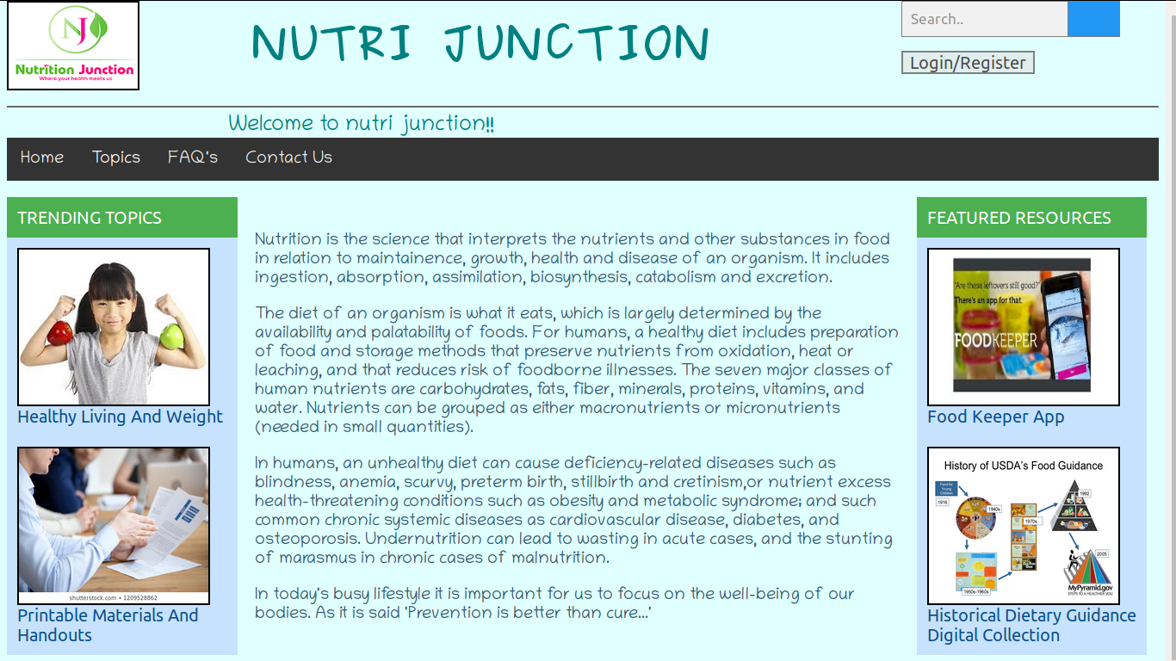
Navigation bar with hover effect and dropdown

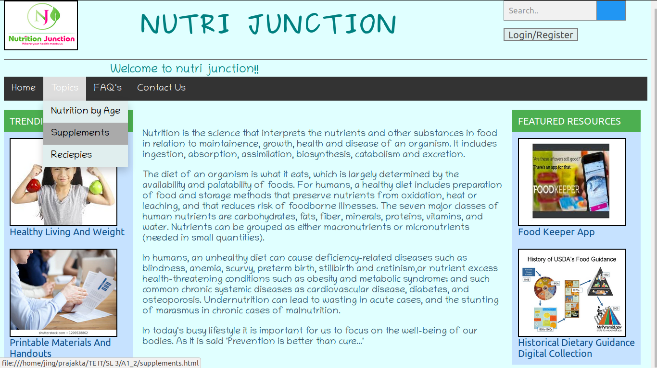
Drop down with hover effect
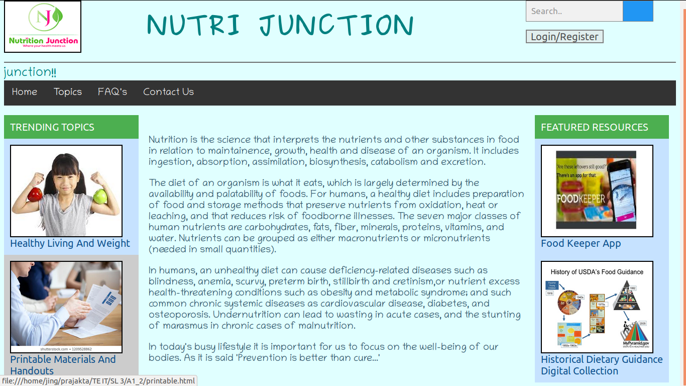
Vertical menu with hover effect
Aligning image and website name

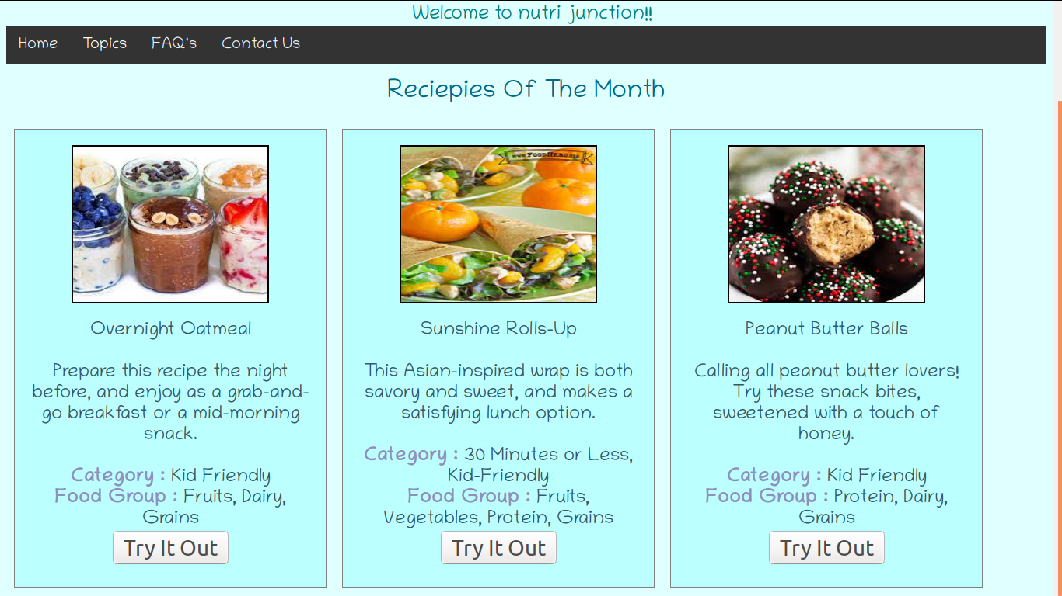
Div tag with spacing between the two divisions
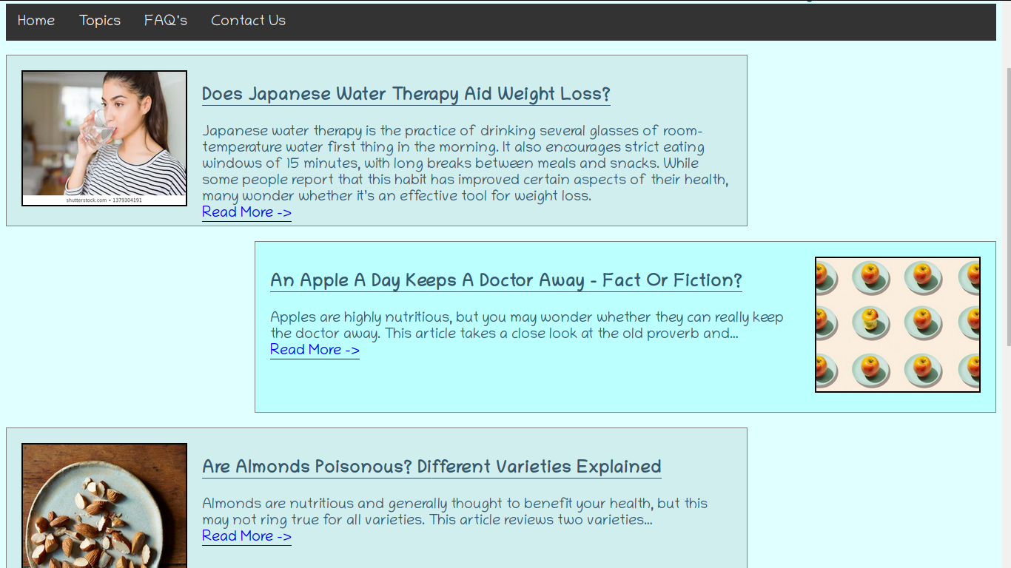
Divisions with alternate left right alignments with vertical spacing

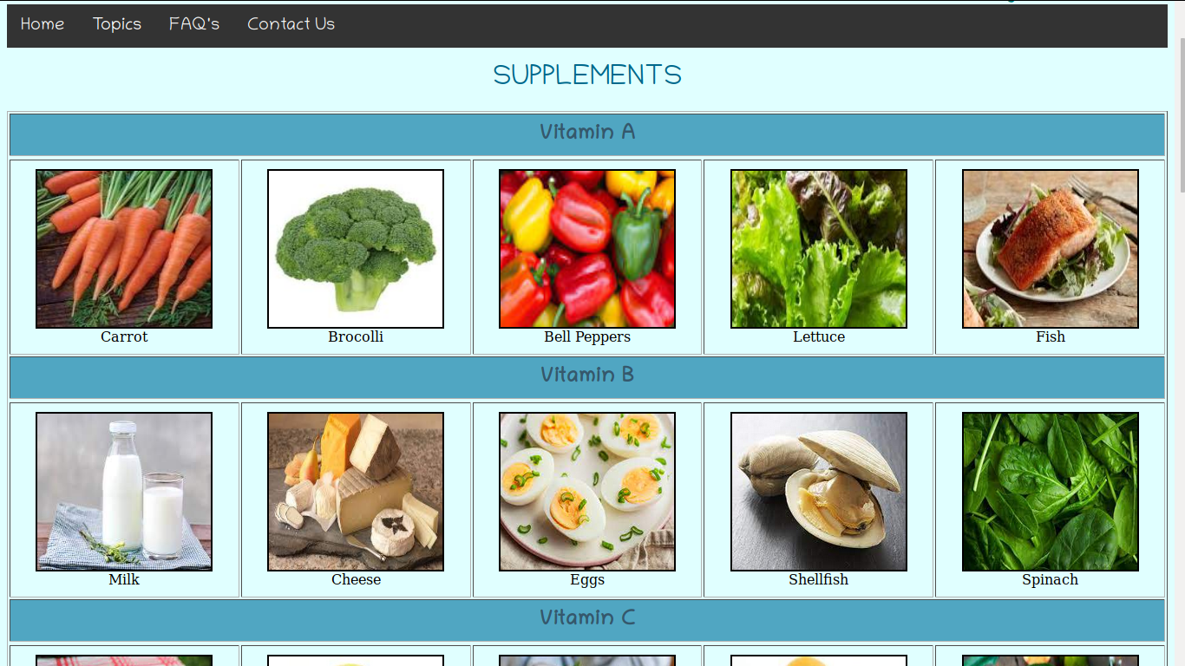
Alignment of images in table with image borders
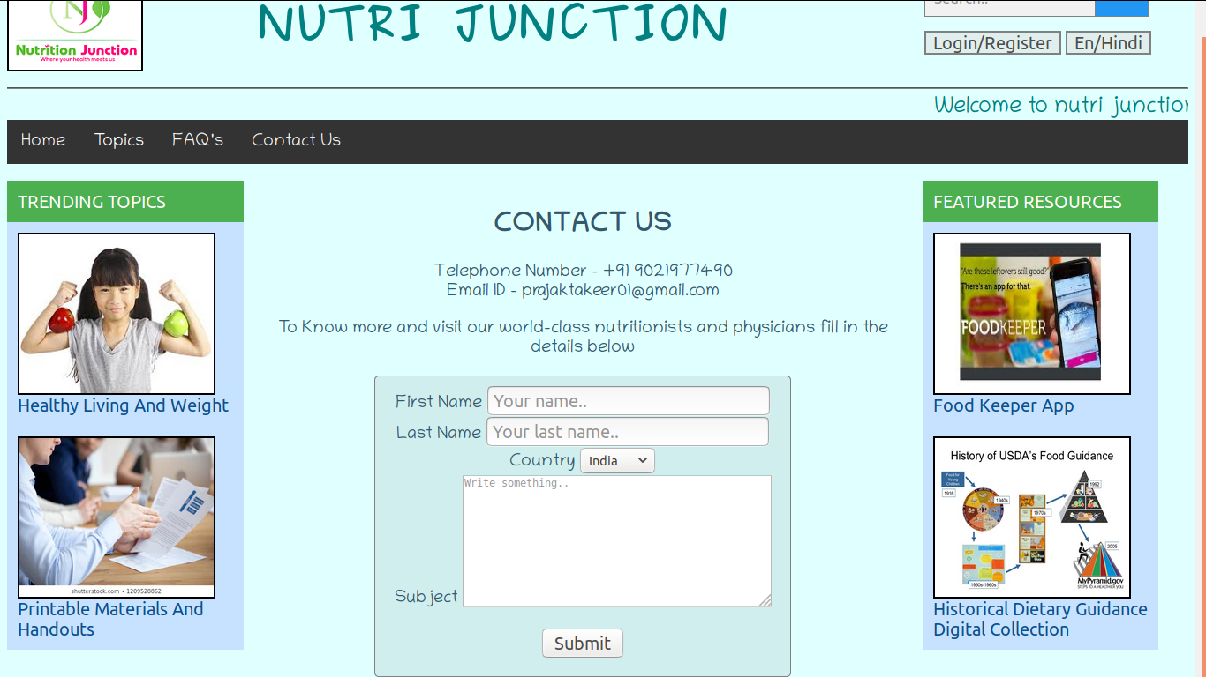
Form with border and center alignment

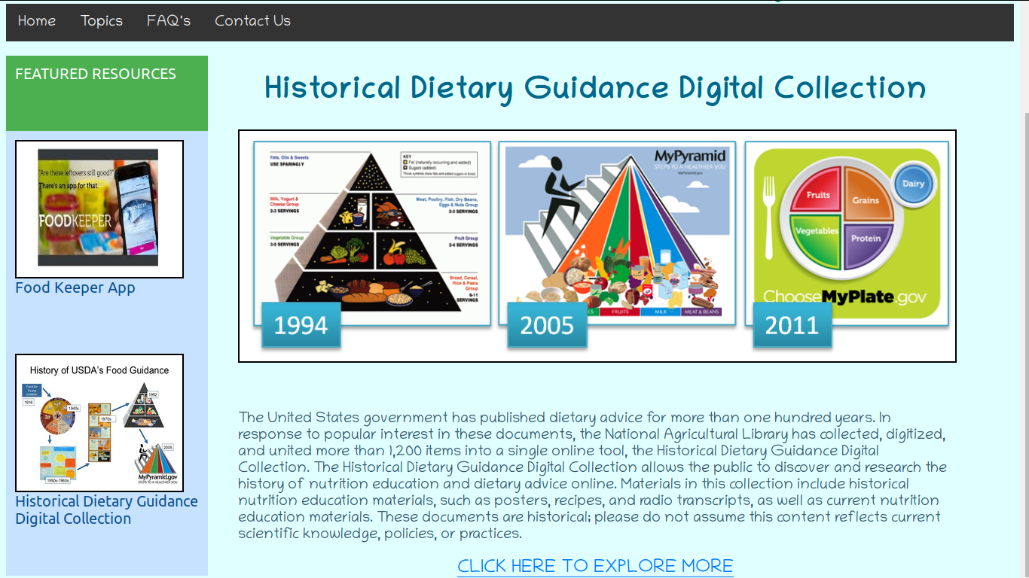
Image with border and full width
Code for nutrition.html page

<html>

<head>
<link rel = "stylesheet" href="nutrition.css">
<title>Nutrition Website</title>
</head>

<body>
<header>
<p>
<div class = "logo"><a href="nutrition.html"><img src = "logo.png"></a></div>
<div class = "title">NUTRI JUNCTION</div>
<div class = "search"><form class="example" action="action_page.php">
<input type="text" placeholder="Search.." name="search">
<button type="submit"><i class="fa fa-search"></i></button>
</form>
<button type="submit" onclick="location.href='feedback.html';">Login/Register</button>
<!button type="submit"><!En/Hindi><!/button>
</div>
</p><br><br><br><br><br><br>
</header>
<hr>

<marquee>Welcome to nutri junction!!</marquee>

<div class="navbar">
<a href="nutrition.html">Home</a>
<div class="dropdown">
<button class="dropbtn">Topics</button>
<div class="dropdown-content">
<a href="nutrition_by_age.html">Nutrition by Age</a>
<a href="supplements.html">Supplements</a>
<a href="reciepies.html">Reciepies</a>
</div>
</div>
<a href="faq.html">FAQ's</a>
<a href="contact.html">Contact Us</a>
<!a href="feedback.html"><!/a>
</div><br>

<div class="vertical-menu">
<a href="#" class="active">TRENDING TOPICS</a>
<a href="healthy_living.html"><img src = "healthy_living.jpeg">Healthy Living And Weight</a>
<a href="printable.html"><img src = "printables.jpg">Printable Materials And Handouts</a>
</div>

<section>
<div class = "middle">
<p>Nutrition is the science that interprets the nutrients and other substances in food in relation to maintainence, growth, health and disease of an organism. It includes ingestion, absorption, assimilation, biosynthesis, catabolism and excretion.</p>

<p>The diet of an organism is what it eats, which is largely determined by the availability and palatability of foods. For humans, a healthy diet includes preparation of food and storage methods that preserve nutrients from oxidation, heat or leaching, and that reduces risk of foodborne illnesses. The seven major classes of human nutrients are carbohydrates, fats, fiber, minerals, proteins, vitamins, and water. Nutrients can be grouped as either macronutrients or micronutrients (needed in small quantities).</p>

<p>In humans, an unhealthy diet can cause deficiency-related diseases such as blindness, anemia, scurvy, preterm birth, stillbirth and cretinism,or nutrient excess health-threatening conditions such as obesity and metabolic syndrome; and such common chronic systemic diseases as cardiovascular disease, diabetes, and osteoporosis. Undernutrition can lead to wasting in acute cases, and the stunting of marasmus in chronic cases of malnutrition.</p>

<p>In today's busy lifestyle it is important for us to focus on the well-being of our bodies. As it is said 'Prevention is better than cure...'
</section></div>

<div class="vertical-menu">
<a href="#" class="active">FEATURED RESOURCES</a>
<a href="food_keeper.html"><img src = "foodkeeper.jpeg">Food Keeper App</a>
<a href="historical_guidance.html"><img src = "hist_guidance.jpg">Historical Dietary Guidance Digital Collection</a>
</div>

</body>
</html>
Code for contact.html page

<html>

<head>
<link rel = "stylesheet" href="nutrition.css">
<title>Nutrition Website</title>
</head>

<body>
<header>
<p>
<div class = "logo"><a href="nutrition.html"><img src = "logo.png"></a></div>
<div class = "title">NUTRI JUNCTION</div>
<div class = "search"><form class="example" action="action_page.php">
<input type="text" placeholder="Search.." name="search">
<button type="submit"><i class="fa fa-search"></i></button>
</form>
<button type="submit">Login/Register</button>
<button type="submit">En/Hindi</button>
</div>
</p><br><br><br><br><br><br>
</header>
<hr>

<marquee>Welcome to nutri junction!!</marquee>

<div class="navbar">
<a href="nutrition.html">Home</a>
<div class="dropdown">
<button class="dropbtn">Topics</button>
<div class="dropdown-content">
<a href="nutrition_by_age.html">Nutrition by Age</a>
<a href="supplements.html">Supplements</a>
<a href="reciepies.html">Reciepies</a>
</div>
</div>
<a href="faq.html">FAQ's</a>
<a href="contact.html">Contact Us</a>
</div><br>

<div class="vertical-menu">
<a href="#" class="active">TRENDING TOPICS</a>
<a href="healthy_living.html"><img src = "healthy_living.jpeg">Healthy Living And Weight</a>
<a href="printable.html"><img src = "printables.jpg">Printable Materials And Handouts</a>
</div>

<section>
<div class = "contact">
<h2>CONTACT US</h2>
<p>Telephone Number - +91 9021977490<br>Email ID - prajaktakeer01@gmail.com</p>
<p>To Know more and visit our world-class nutritionists and physicians fill in the details below</p>

<div class = "form">
<form action="/action_page.php">
<label for="fname">First Name</label>
<input type="text" id="fname" name="firstname" placeholder="Your name.."><br>
<label for="lname">Last Name</label>
<input type="text" id="lname" name="lastname" placeholder="Your last name.."><br>
<label for="country">Country</label>
<select id="country" name="country">
<option value="australia">India</option>
<option value="canada">Canada</option>
<option value="usa">USA</option>
</select><br>
<label for="subject">Subject</label>
<textarea id="subject" name="subject" placeholder="Write something.." style="height:150px; width:350px"></textarea><br><br>
<input type="submit" value="Submit">
</form></font>
</section></div></div>

<div class="vertical-menu">
<a href="#" class="active">FEATURED RESOURCES</a>
<a href="food_keeper.html"><img src = "foodkeeper.jpeg">Food Keeper App</a>
<a href="historical_guidance.html"><img src = "hist_guidance.jpg">Historical Dietary Guidance Digital Collection</a>
</div>

</body>
</html>
Source code for faq.html
<html>

<head>
<link rel = "stylesheet" href="nutrition.css">
<title>Nutrition Website</title>
</head>

<body>
<header>
<p>
<div class = "logo"><a href="nutrition.html"><img src = "logo.png"></a></div>
<div class = "title">NUTRI JUNCTION</div>
<div class = "search"><form class="example" action="action_page.php">
<input type="text" placeholder="Search.." name="search">
<button type="submit"><i class="fa fa-search"></i></button>
</form>
<button type="submit">Login/Register</button>
<button type="submit">En/Hindi</button>
</div>
</p><br><br><br><br><br><br>
</header>
<hr>

<marquee>Welcome to nutri junction!!</marquee>

<div class="navbar">
<a href="nutrition.html">Home</a>
<div class="dropdown">
<button class="dropbtn">Topics</button>
<div class="dropdown-content">
<a href="nutrition_by_age.html">Nutrition by Age</a>
<a href="supplements.html">Supplements</a>
<a href="reciepies.html">Reciepies</a>
</div>
</div>
<a href="faq.html">FAQ's</a>
<a href="contact.html">Contact Us</a>
</div><br>

<div class = "water">
<div class = "water_img"><img src = "drink_water.webp"></img></div>
<div class = "water_text"><h3><u>Does Japanese Water Therapy Aid Weight Loss?</h3></u>
<p>Japanese water therapy is the practice of drinking several glasses of room-temperature water first thing in the morning.
It also encourages strict eating windows of 15 minutes, with long breaks between meals and snacks.
While some people report that this habit has improved certain aspects of their health, many wonder whether it’s an effective tool for weight loss.<br>
<a href = "https://www.healthline.com/nutrition/water-therapy-for-weight-loss-does-it-work#1">Read More -></a></div></p>
</div>

<div class = "apples">
<div class = "apple_img"><img src = "apples.jpg"></img></div>
<div class = "apple_text"><h3><u>An Apple A Day Keeps A Doctor Away - Fact Or Fiction?</h3></u>
<p>Apples are highly nutritious, but you may wonder whether they can really keep the doctor away. This article takes a close look at the old proverb and… <br>
<a href = "https://www.healthline.com/nutrition/an-apple-a-day-keeps-the-doctor-away#1">Read More -></a></div></p>
</div>

<div class = "water">
<div class = "water_img"><img src = "almonds.jpg"></img></div>
<div class = "water_text"><h3><u>Are Almonds Poisonous? Different Varieties Explained</h3></u>
<p>Almonds are nutritious and generally thought to benefit your health, but this may not ring true for all varieties. This article reviews two varieties…<br>
<a href = "https://www.healthline.com/nutrition/are-almonds-poisonous#1">Read More -></a></div></p>
</div>

<div class = "apples">
<div class = "apple_img"><img src = "lab_milk.jpg"></img></div>
<div class = "apple_text"><h3><u>What Is Lab Milk? Benefits and Drawbacks</h3></u>
<p>You may have heard of meat grown in laboratories, but lab-grown milk is on the horizon as well. This article tells you all you need to know about lab…<br>
<a href = "https://www.healthline.com/nutrition/lab-milk#1">Read More -></a></div></p>
</div>

<div class = "water">
<div class = "water_img"><img src = "sugar.jpg"></img></div>
<div class = "water_text"><h3><u>The 56 Most Common Names for Sugar (Some Are Tricky)</h3></u>
<p>Learn the names of 56 different types of sugar, such as sucrose and agave nectar. Also discover some foods that may contain them.<br>
<a href = "https://www.healthline.com/nutrition/56-different-names-for-sugar#1">Read More -></a></div></p>
</div>

</body>
</html>
Source code for reciepies.html

<html>

<head>
<link rel = "stylesheet" href="nutrition.css">
<title>Nutrition Website</title>
</head>

<body>
<header>
<p>
<div class = "logo"><a href="nutrition.html"><img src = "logo.png"></a></div>
<div class = "title">NUTRI JUNCTION</div>
<div class = "search"><form class="example" action="action_page.php">
<input type="text" placeholder="Search.." name="search">
<button type="submit"><i class="fa fa-search"></i></button>
</form>
<button type="submit">Login/Register</button>
<button type="submit">En/Hindi</button>
</div>
</p><br><br><br><br><br><br>
</header>
<hr>

<marquee>Welcome to nutri junction!!</marquee>

<div class="navbar">
<a href="nutrition.html">Home</a>
<div class="dropdown">
<button class="dropbtn">Topics</button>
<div class="dropdown-content">
<a href="nutrition_by_age.html">Nutrition by Age</a>
<a href="supplements.html">Supplements</a>
<a href="reciepies.html">Reciepies</a>
</div>
</div>
<a href="faq.html">FAQ's</a>
<a href="contact.html">Contact Us</a>
</div><br>

<center><font size = "6" color = "#00688B" face = "Chilanka">Reciepies Of The Month</font></center><br>

<div class = "reciepe1">
<img src = "oatmeal.jpeg"><br><br><font color = "#35586C" face = "Chilanka" size = "5"><u>Overnight Oatmeal</u><br><br>Prepare this recipe the night before, and enjoy as a grab-and-go breakfast or a mid-morning snack.<br><br><font color = "#8F8FBC" face = "Chilanka" size = "5"><b>Category : </b><font color = "#35586C" face = "Chilanka" size = "5">Kid Friendly<br><font color = "#8F8FBC" face = "Chilanka" size = "5"><b>Food Group : </b><font color = "#35586C" face = "Chilanka" size = "5">Fruits, Dairy, Grains<br><button style = "font-size: 28px;" onclick="location.href='https://www.nutrition.gov/recipes/overnight-oatmeal';">Try It Out</button>
</div>

<div class = "reciepe1">
<img src = "rolls.jpeg"><br><br><font color = "#35586C" face = "Chilanka" size = "5"><u>Sunshine Rolls-Up</u><br><br>This Asian-inspired wrap is both savory and sweet, and makes a satisfying lunch option.<br><br><font color = "#8F8FBC" face = "Chilanka" size = "5"><b>Category : </b><font color = "#35586C" face = "Chilanka" size = "5"> 30 Minutes or Less, Kid-Friendly <br><font color = "#8F8FBC" face = "Chilanka" size = "5"><b>Food Group : </b><font color = "#35586C" face = "Chilanka" size = "5"> Fruits, Vegetables, Protein, Grains <br><button style = "font-size: 28px;" onclick="location.href='https://www.nutrition.gov/recipes/sunshine-roll-ups';">Try It Out</button>
</div>

<div class = "reciepe1">
<img src = "peanut.jpeg"><br><br><font color = "#35586C" face = "Chilanka" size = "5"><u>Peanut Butter Balls</u><br><br>Calling all peanut butter lovers! Try these snack bites, sweetened with a touch of honey.<br><br><font color = "#8F8FBC" face = "Chilanka" size = "5"><b>Category : </b><font color = "#35586C" face = "Chilanka" size = "5">Kid Friendly<br><font color = "#8F8FBC" face = "Chilanka" size = "5"><b>Food Group : </b><font color = "#35586C" face = "Chilanka" size = "5"> Protein, Dairy, Grains <br><button style = "font-size: 28px;" onclick="location.href='https://www.nutrition.gov/recipes/peanut-butter-balls';">Try It Out</button>
</div>

</body>
</html>
Source code for nutrition.css

background color for webpage
body {
background-color : #E0FFFF;
}

.logo img {
height: 100px;
width: 150px;
border: 2px solid transparent;
border-color:black;
}

aligning title to the right of website logo
.title {
float: left;
background: #E0FFFF;
font-family : Purisa;
font-size: 50px;
padding:20px;
color:#008080;
font-weight:bold;
line-height: 65px;
text-align:center;
width:750px;
}

.search {
float:right;
}

.search button {
font-size:20px;
background:#E0EEEE;
cursor : pointer;
border : 2px solid grey;
}

/* Style the search field */
.search form.example input[type=text] {
padding: 10px;
font-size: 17px;
border: 1px solid grey;
float: left;
width: 65%;
background: #f1f1f1;
}

/* Style the submit button */
.search form.example button {
float: left;
width: 20%;
height:42px;
padding: 10px;
background: #2196F3;
color: white;
font-size: 50px;
border: 1px solid grey;
border-left: none; /* Prevent double borders */
cursor: pointer;
}

.search form.example button:hover {
background: #0b7dda;
}

/* Clear floats */
.search form.example::after {
content: "";
clear: both;
display: table;
}

marquee for scrolling text
marquee {
font-family:Chilanka;
color:#008080;
font-size:25px;
}

nav {
float: left;
width: 18%;
height: 520px;
background: #E0EEEE;
padding: 20px;
}

/*.featured_resources nav {
float: right;
width: 18%;
height: 520px;
background: #222;
padding: 20px;
}*/

.middle {
float: left;
width: 56%;
height: 500px;
background: #E0FFFF;
padding: 20px;
font-family:Chilanka;
font-size:20px;
color:#35586C;
}

.navbar {
overflow: hidden;
background-color: #333;
width: 100%; /* Full width */
}

navbar with hover effect
/* Links inside the navbar */
.navbar a {
float: left;
display: block;
color: #f2f2f2;
text-align: center;
padding: 14px 16px;
text-decoration: none;
font-family:Chilanka;
font-size:20px;
}

/* Change background on mouse-over */
.navbar a:hover {
background: #ddd;
color: black;
}

.logo {
float: left;
background: #D1EEEE;
padding: 0px;
}

creating drop down menu
/* The dropdown container */
.dropdown {
float: left;
overflow: hidden;
}

/* Dropdown button */
.dropdown .dropbtn {
font-size: 16px;
border: none;
outline: none;
color: white;
padding: 14px 16px;
background-color: inherit;
/*font-family: inherit; Important for vertical align on mobile phones */
margin: 0; /* Important for vertical align on mobile phones */
font-family:Chilanka;
font-size:20px;
}

/* Add a red background color to navbar links on hover */
.navbar a:hover, .dropdown:hover .dropbtn {
background-color: #ddd;
}

/* Dropdown content (hidden by default) */
.dropdown-content {
display: none;
position: absolute;
background-color: #E0EEEE;
min-width: 160px;
box-shadow: 0px 8px 16px 0px rgba(0,0,0,0.2);
z-index: 1;
font-family:Chilanka;
}

/* Links inside the dropdown */
.dropdown-content a {
float: none;
color: black;
padding: 12px 16px;
text-decoration: none;
display: block;
text-align: left;
}

/* Add a grey background color to dropdown links on hover */
.dropdown-content a:hover {
background-color: #aaa;
}

/* Show the dropdown menu on hover */
.dropdown:hover .dropdown-content {
display: block;
}

creating a vertical menu for side sections(trending topics and featured resources)
.vertical-menu img {
height: 180px;
width: 220px;
border: 2px solid transparent;
border-color:black;
}

.vertical-menu {
width: 20%; /* Set a width if you like */
float:left;
font-size: 20px;
font-family:Ubuntu;
}

.vertical-menu a {
background-color: #C6E2FF; /* Grey background color */
color: #0D4F8B; /* Black text color */
display: block; /* Make the links appear below each other */
padding: 12px; /* Add some padding */
text-decoration: none; /* Remove underline from links */
}

.vertical-menu a:hover {
background-color: #ccc; /* Dark grey background on mouse-over */
}

.vertical-menu a.active {
background-color: #4CAF50; /* Add a green color to the "active/current" link */
color: white;
}

.contact {
float: left;
width: 56%;
height: 500px;
background: #E0FFFF;
padding: 10px;
font-family:Chilanka;
font-size:20px;
color:#35586C;
text-align:center;
}

creating form for contact page with border and aligned input fields
.form {
border-radius: 5px;
background-color: #D1EEEE;
padding: 10px;
margin: 0 auto;
width: 450px;
border: 1px solid transparent;
border-color:grey;
height:320px;
}

.form input {
font-size:20px;
}

creating alternate right left alignments of division with vertical spacing for faq page
.water {
float:left;
background-color: #D1EEEE;
width:1000px;
height:230px;
border: 1px solid transparent;
border-color:grey;
margin-bottom: 20px;
}

adding image borders
.water img {
height: 180px;
width: 220px;
border: 2px solid transparent;
border-color:black;
}

.water_img {
float:left;
padding:20px;
}

.water_text {
font-family : Chilanka;
font-size: 20px;
padding:20px;
color:#35586C;
}

.apples {
float:right;
background-color: #BBFFFF;
width:1000px;
height:230px;
border: 1px solid transparent;
border-color:grey;
margin-bottom: 20px;
}

.apples img {
height: 180px;
width: 220px;
border: 2px solid transparent;
border-color:black;
}

.apple_img {
float:right;
padding:20px;
}

.apple_text {
font-family : Chilanka;
font-size: 20px;
padding:20px;
color:#35586C;
}

creating divisions with horizontal spacing between two divisions for reciepies page
.reciepe1 {
font-family : Chilanka;
font-size: 20px;
padding:20px;
border: 1px solid transparent;
border-color:grey;
background-color: #BBFFFF;
float : left;
text-align : center;
width : 360px;
height : 550px;
margin : 10px;
}

.reciepe1 img {
height: 200px;
width: 250px;
border: 2px solid transparent;
border-color:black;
}

.reciepe:hover {
background-color: #ccc;
}

.healthy_living {
float:left;
padding-left:40px;
width:950px;
height:300px;
font-family:Chilanka;
font-size:20px;
}

.hl-menu img {
height: 180px;
width: 220px;
border: 2px solid transparent;
border-color:black;
}

.hl-menu {
width: 20%; /* Set a width if you like */
height:500px;
float:left;
font-size: 20px;
font-family:Ubuntu;
}

.hl-menu a {
background-color: #C6E2FF; /* Grey background color */
color: #0D4F8B; /* Black text color */
display: block; /* Make the links appear below each other */
padding: 12px;
padding-bottom:65px; /* Add some padding */
text-decoration: none; /* Remove underline from links */
}

.hl-menu a:hover {
background-color: #ccc; /* Dark grey background on mouse-over */
}

.hl-menu a.active {
background-color: #4CAF50; /* Add a green color to the "active/current" link */
color: white;
}

Source code for supplements.html

<html>

<head>
<link rel = "stylesheet" href="nutrition.css">
<title>Nutrition Website</title>
</head>

<body>
<header>
<p>
<div class = "logo"><a href="nutrition.html"><img src = "logo.png"></a></div>
<div class = "title">NUTRI JUNCTION</div>
<div class = "search"><form class="example" action="action_page.php">
<input type="text" placeholder="Search.." name="search">
<button type="submit"><i class="fa fa-search"></i></button>
</form>
<button type="submit">Login/Register</button>
<button type="submit">En/Hindi</button>
</div>
</p><br><br><br><br><br><br>
</header>
<hr>

<marquee>Welcome to nutri junction!!</marquee>

<div class="navbar">
<a href="nutrition.html">Home</a>
<div class="dropdown">
<button class="dropbtn">Topics</button>
<div class="dropdown-content">
<a href="nutrition_by_age.html">Nutrition by Age</a>
<a href="supplements.html">Supplements</a>
<a href="reciepies.html">Reciepies</a>
</div>
</div>
<a href="faq.html">FAQ's</a>
<a href="contact.html">Contact Us</a>
</div><br>

<center><font size = "6" color = "#00688B" face = "Chilanka">SUPPLEMENTS</font></center><br>

<table border = "1" width = "100%" cellpadding = "10">

<tr>
<th colspan = "5" style = "background-color: #50A6C2;"><font color = "#35586C" face = "Chilanka" size = "5">Vitamin A</font>
<tr>

<tr>
<td style="text-align:center"><img src = "carrot.jpeg" height = "180" width = "200" border = "2"><br>Carrot<br>
<td style="text-align:center"><img src = "brocolli.jpeg" height = "180" width = "200" border = "2"><br>Brocolli<br>
<td style="text-align:center"><img src = "bell_pepper.jpeg" height = "180" width = "200" border = "2"><br>Bell Peppers<br>
<td style="text-align:center"><img src = "lettuce.jpeg" height = "180" width = "200" border = "2"><br>Lettuce<br>
<td style="text-align:center"><img src = "fish.jpeg" height = "180" width = "200" border = "2"><br>Fish<br>
</tr>

<tr>
<th colspan = "5" style = "background-color: #50A6C2;"><font color = "#35586C" face = "Chilanka" size = "5">Vitamin B</font>
<tr>

<tr>
<td style="text-align:center"><img src = "milk.jpeg" height = "180" width = "200" border = "2"><br>Milk
<td style="text-align:center"><img src = "cheese.jpeg" height = "180" width = "200" border = "2"><br>Cheese
<td style="text-align:center"><img src = "eggs.jpeg" height = "180" width = "200" border = "2"><br>Eggs
<td style="text-align:center"><img src = "shellfish.jpeg" height = "180" width = "200" border = "2"><br>Shellfish
<td style="text-align:center"><img src = "spianch.jpeg" height = "180" width = "200" border = "2"><br>Spinach
</tr>

<tr>
<th colspan = "5" style = "background-color: #50A6C2;"><font color = "#35586C" face = "Chilanka" size = "5">Vitamin C</font>
<tr>

<tr>
<td style="text-align:center"><img src = "tomatoes.jpeg" height = "180" width = "200" border = "2"><br>Tomatoes
<td style="text-align:center"><img src = "lemon.jpeg" height = "180" width = "200" border = "2"><br>Lemon
<td style="text-align:center"><img src = "strawberry.jpeg" height = "180" width = "200" border = "2"><br>Strawberries
<td style="text-align:center"><img src = "orange.jpeg" height = "180" width = "200" border = "2"><br>Orange
<td style="text-align:center"><img src = "guava.jpeg" height = "180" width = "200" border = "2"><br>Guava
</tr>

<tr>
<th colspan = "5" style = "background-color: #50A6C2;"><font color = "#35586C" face = "Chilanka" size = "5">Vitamin D</font>
<tr>

<tr>
<td style="text-align:center"><img src = "salmon.jpeg" height = "180" width = "200" border = "2"><br>Fish(Salmon)
<td style="text-align:center"><img src = "mushroom.jpeg" height = "180" width = "200" border = "2"><br>Mushrooms
<td style="text-align:center"><img src = "tofu.jpeg" height = "180" width = "200" border = "2"><br>Tofu
<td style="text-align:center"><img src = "yoghurt.jpeg" height = "180" width = "200" border = "2"><br>Yoghurt
<td style="text-align:center"><img src = "soy_milk.jpeg" height = "180" width = "200" border = "2"><br>Soy Milk
</tr>

<tr>
<th colspan = "5" style = "background-color: #50A6C2;"><font color = "#35586C" face = "Chilanka" size = "5">Vitamin E</font>
<tr>

<tr>
<td style="text-align:center"><img src = "almonds.jpg" height = "180" width = "200" border = "2"><br>Almonds
<td style="text-align:center"><img src = "avocado.jpeg" height = "180" width = "200" border = "2"><br>Avocado
<td style="text-align:center"><img src = "kiwi.jpeg" height = "180" width = "200" border = "2"><br>Kiwi
<td style="text-align:center"><img src = "olive_oil.jpeg" height = "180" width = "200" border = "2"><br>Olive Oil
<td style="text-align:center"><img src = "shrimp.jpeg" height = "180" width = "200" border = "2"><br>Shrimp
</tr>

<tr>
<th colspan = "5" style = "background-color: #50A6C2;"><font color = "#35586C" face = "Chilanka" size = "5">Vitamin K</font>
<tr>

<tr>
<td style="text-align:center"><img src = "cabbage.jpeg" height = "180" width = "200" border = "2"><br>Cabbage
<td style="text-align:center"><img src = "cucumber.jpeg" height = "180" width = "200" border = "2"><br>Cucumber
<td style="text-align:center"><img src = "asparagus.jpeg" height = "180" width = "200" border = "2"><br>Asparagus
<td style="text-align:center"><img src = "okra.jpeg" height = "180" width = "200" border = "2"><br>Okra
<td style="text-align:center"><img src = "green_beans.jpeg" height = "180" width = "200" border = "2"><br>Green Beans
</tr>

<tr>
<th colspan = "5" style = "background-color: #50A6C2;"><font color = "#35586C" face = "Chilanka" size = "5">Calcium</font>
<tr>

<tr>
<td style="text-align:center"><img src = "paneer.jpeg" height = "180" width = "200" border = "2"><br>Paneer
<td style="text-align:center"><img src = "grated_parmesan.jpeg" height = "180" width = "200" border = "2"><br>Grated Parmesan
<td style="text-align:center"><img src = "cowpeas.jpeg" height = "180" width = "200" border = "2"><br>Cowpeas
<td style="text-align:center"><img src = "trout.jpeg" height = "180" width = "200" border = "2"><br>Trout
<td style="text-align:center"><img src = "clams.jpeg" height = "180" width = "200" border = "2"><br>Clams
</tr>

<tr>
<th colspan = "5" style = "background-color: #50A6C2;"><font color = "#35586C" face = "Chilanka" size = "5">Sodium</font>
<tr>

<tr>
<td style="text-align:center"><img src = "cereals.jpeg" height = "180" width = "200" border = "2"><br>Cereals
<td style="text-align:center"><img src = "oysters.jpeg" height = "180" width = "200" border = "2"><br>Oysters
<td style="text-align:center"><img src = "apricot.jpeg" height = "180" width = "200" border = "2"><br>Apricots
<td style="text-align:center"><img src = "quinoa.jpeg" height = "180" width = "200" border = "2"><br>Quinoa
<td style="text-align:center"><img src = "pumpkin_seeds.jpeg" height = "180" width = "200" border = "2"><br>Pumpkin Seeds
</tr>

<tr>
<th colspan = "5" style = "background-color: #50A6C2;"><font color = "#35586C" face = "Chilanka" size = "5">Iron</font>
<tr>

<tr>
<td style="text-align:center"><img src = "table_salt.jpeg" height = "180" width = "200" border = "2"><br>Table Salt
<td style="text-align:center"><img src = "sunflower_seeds.jpeg" height = "180" width = "200" border = "2"><br>Sunflower Seeds
<td style="text-align:center"><img src = "canned_beans.jpeg" height = "180" width = "200" border = "2"><br>Canned Beans
<td style="text-align:center"><img src = "french_bread.jpeg" height = "180" width = "200" border = "2"><br>French Bread
<td style="text-align:center"><img src = "teriyaki.jpeg" height = "180" width = "200" border = "2"><br>Teriyaki Sauce
</tr>

<tr>
<th colspan = "5" style = "background-color: #50A6C2;"><font color = "#35586C" face = "Chilanka" size = "5">Protein</font>
<tr>

<tr>
<td style="text-align:center"><img src = "chicken.jpeg" height = "180" width = "200" border = "2"><br>Chicken
<td style="text-align:center"><img src = "tuna.jpeg" height = "180" width = "200" border = "2"><br>Tuna
<td style="text-align:center"><img src = "lentils.jpeg" height = "180" width = "200" border = "2"><br>Lentils
<td style="text-align:center"><img src = "peanuts.jpeg" height = "180" width = "200" border = "2"><br>Peanuts
<td style="text-align:center"><img src = "cottage_cheese.jpeg" height = "180" width = "200" border = "2"><br>Cottage Cheese
</tr>

</table>

</body>
</html>

References:

1) https://www.w3schools.com/
2) https://www.nutrition.gov/
3) https://www.healthline.com/

